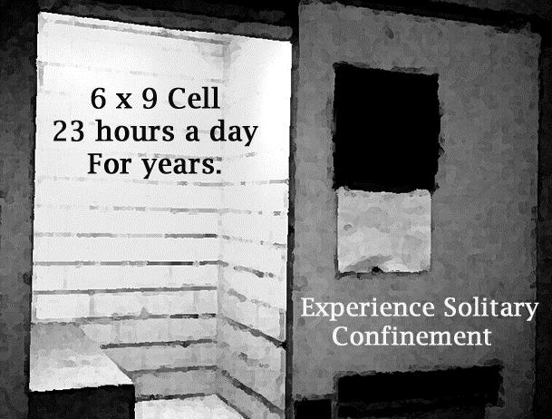
Experience what it is like to live in solitary confinement in a SHU Cell Replica.

Where:
When:
Contact:
[Additional information]



