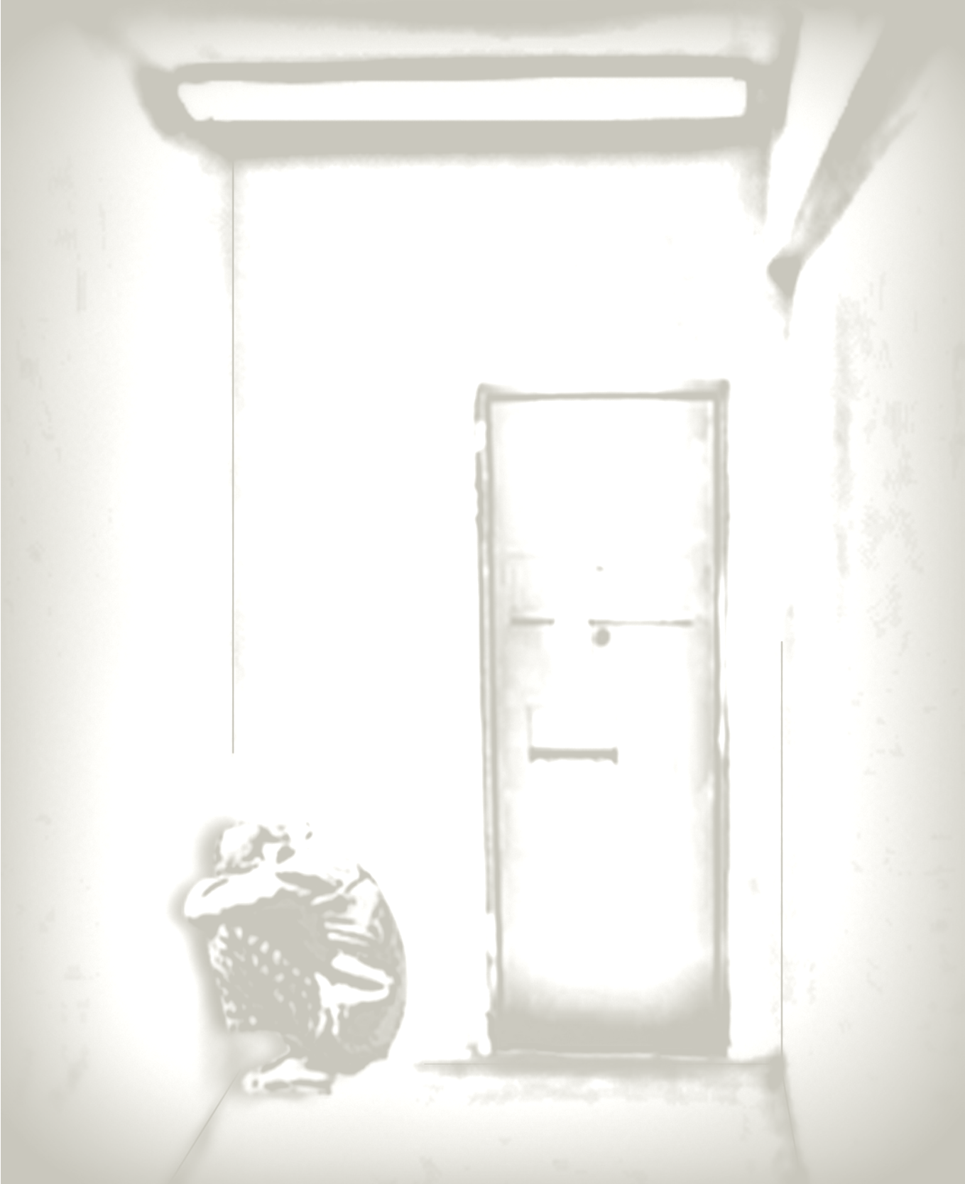
Solitary Confinement:
Torture in Your Backyard

60 square feet.
No human contact.
23 hours per day.
For weeks.
Even years.

Film &
Discussion

DATE

TIME

LOCATION

CONTACT NAME
PHONE
EMAIL

\

